Session 3:

I am going to spinup Two instance and one LB so that we can distribute the load.

1. I will setup instance and deploy any web application.
2. We are going to configure the web app through userdata at the time of Instance launch.
3. Need to setup the LB and add the instances with the same.
4. Once successfully configured. Hit the load balancer dns.

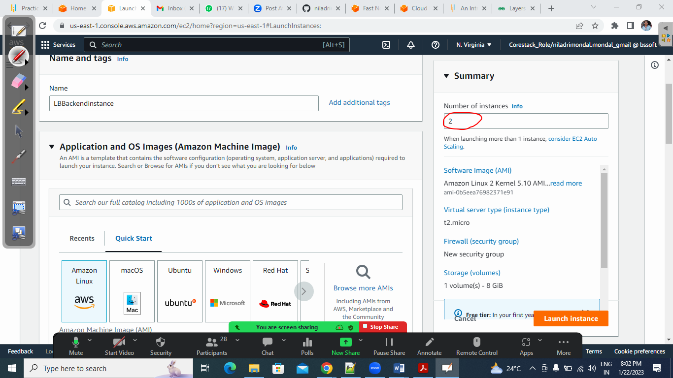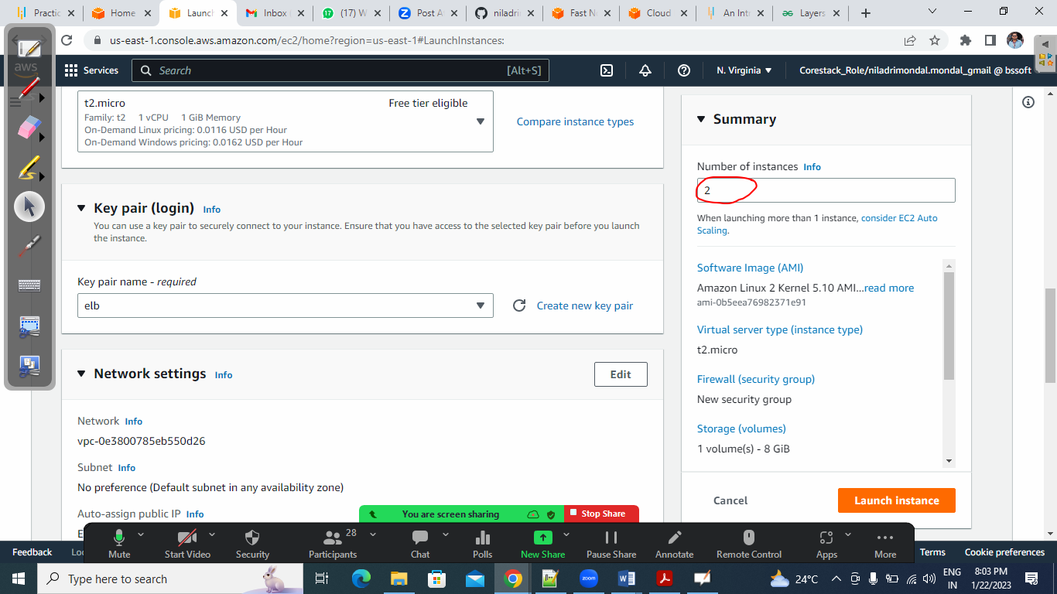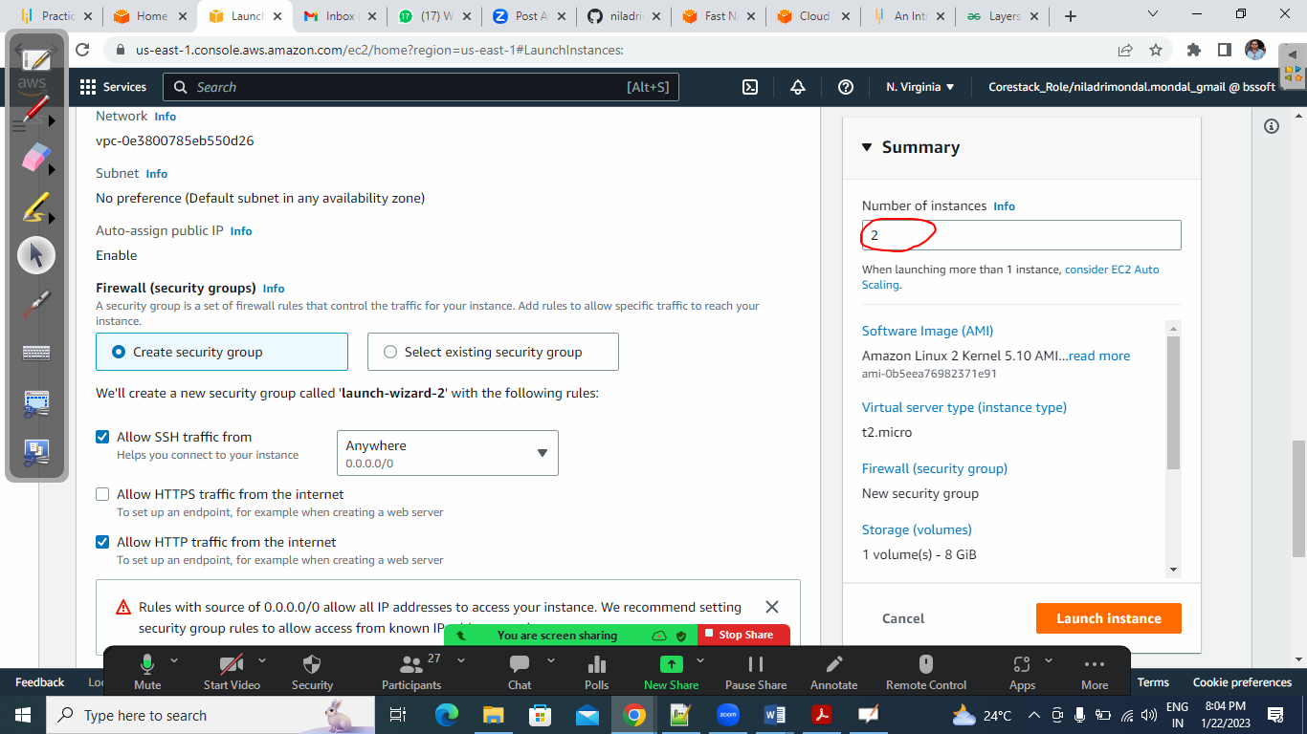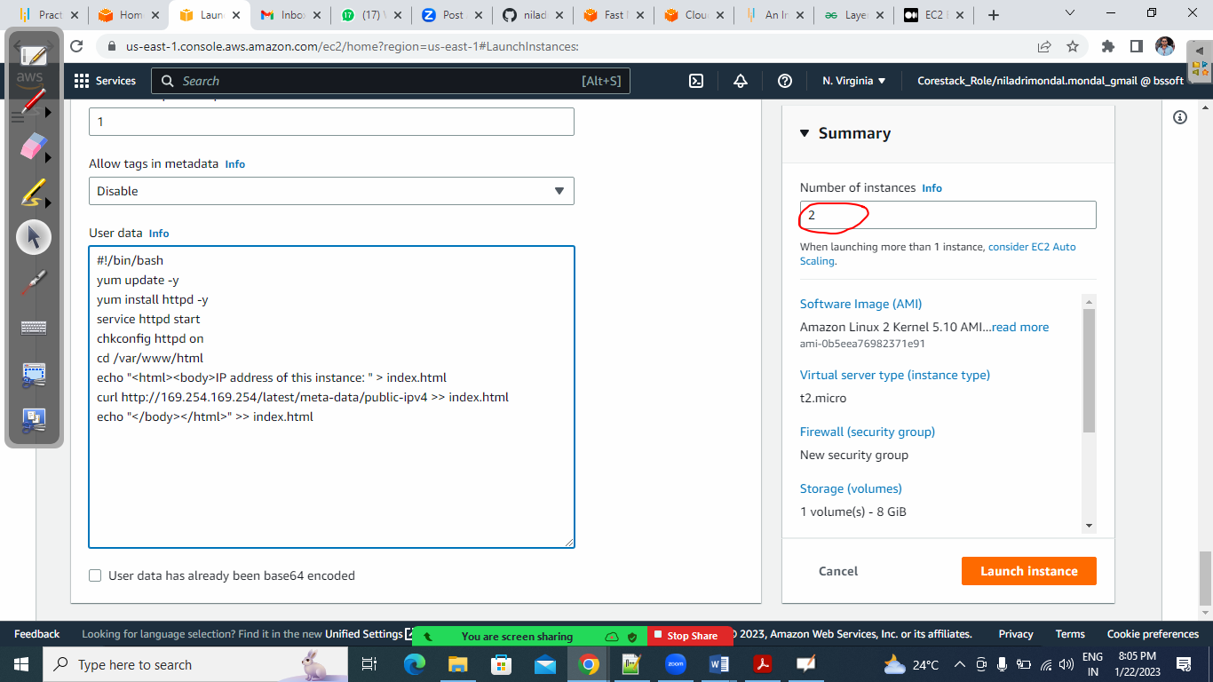

Elastic Load Balancer:

https://medium.com/@KerrySheldon/ec2-exercise-1-4-host-a-static-webpage-behind-a-load-balancer-26762f7190a2

https://docs.aws.amazon.com/elasticloadbalancing/latest/classic/elb-getting-started.html

<https://www.simplilearn.com/tutorials/aws-tutorial/aws-auto-scaling>

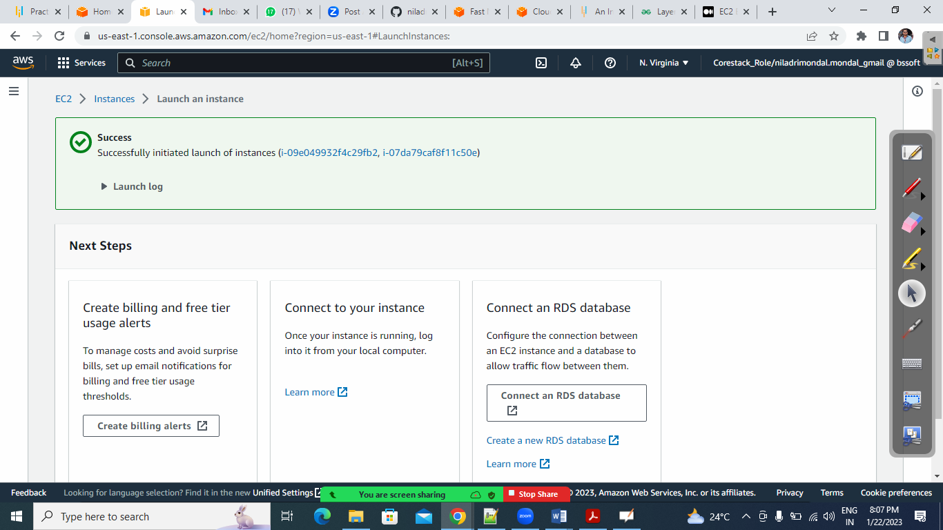

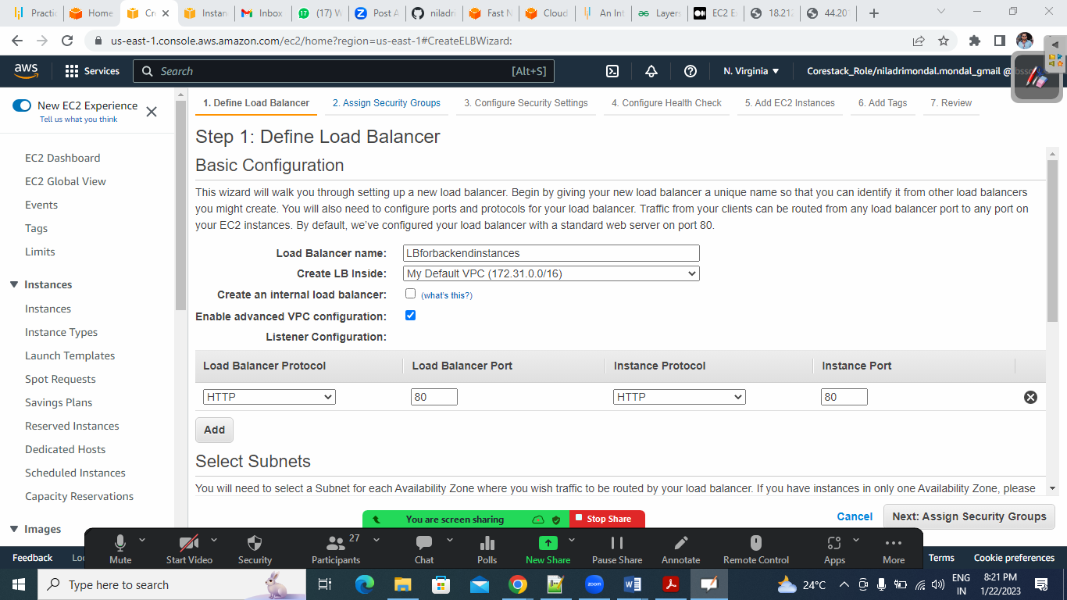

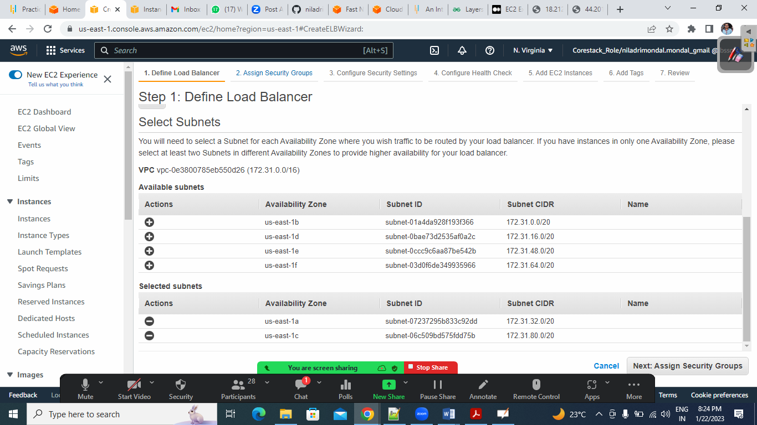

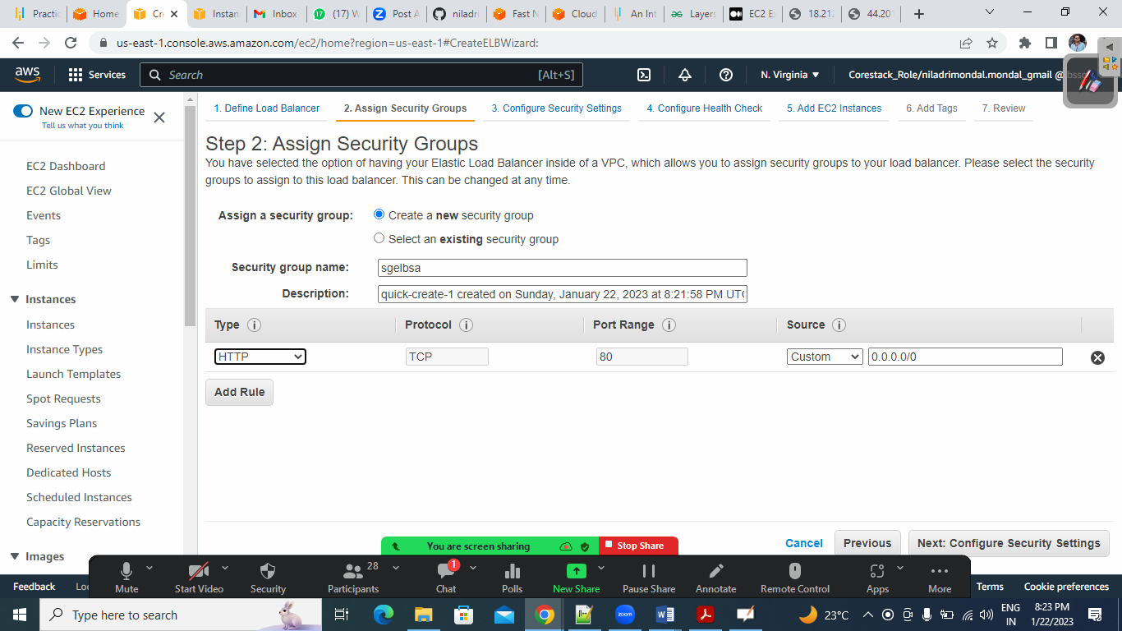

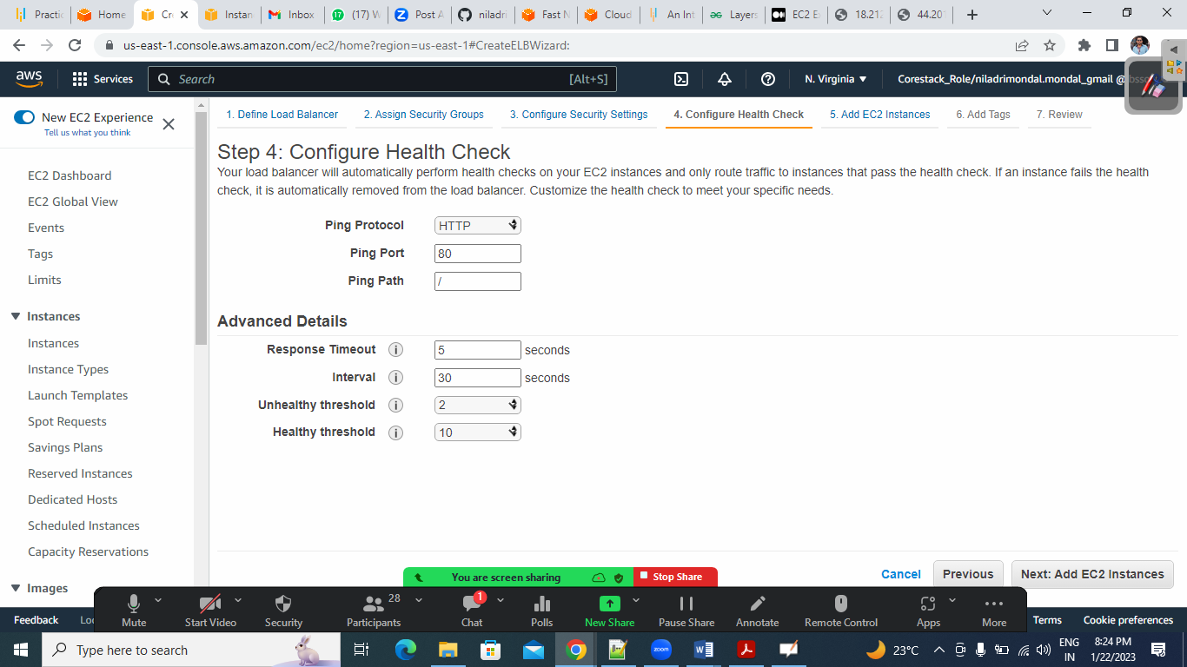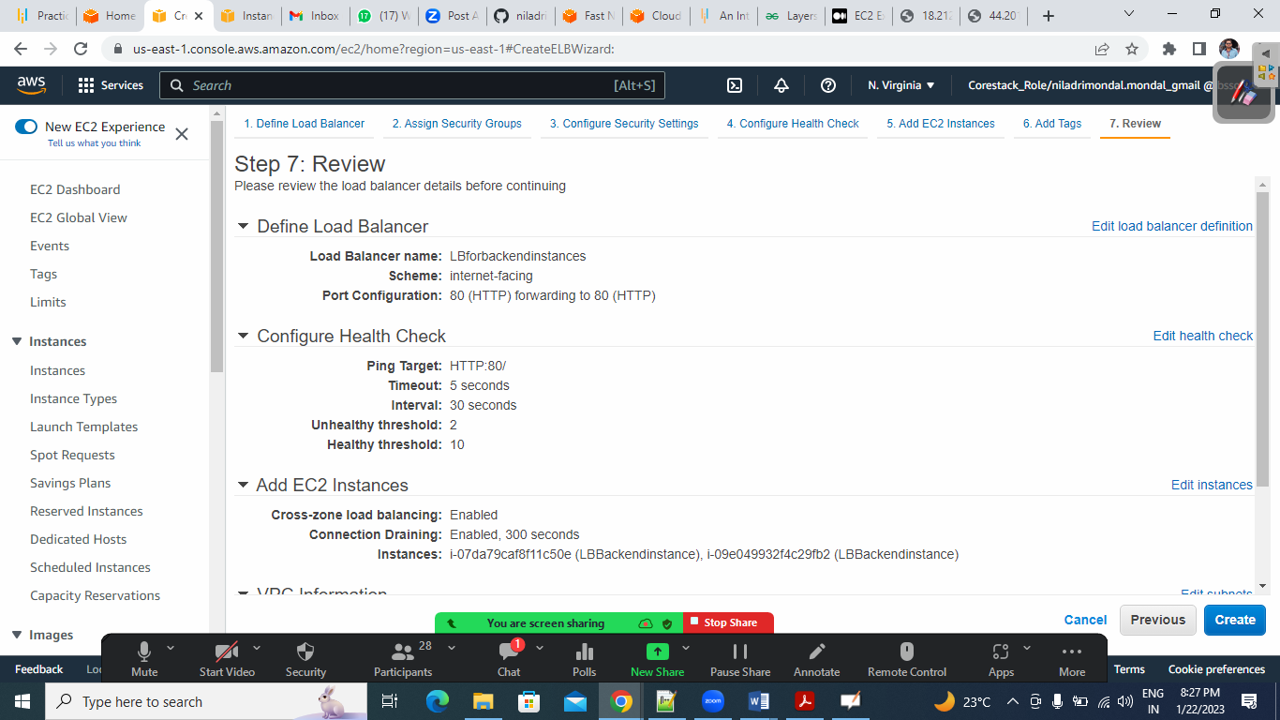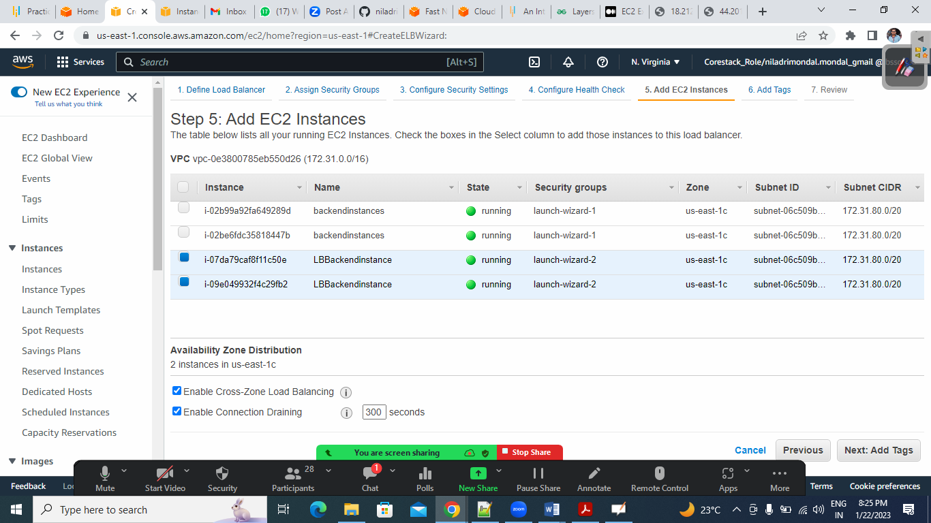

Kubernetes- K8s

